Answers 4.5
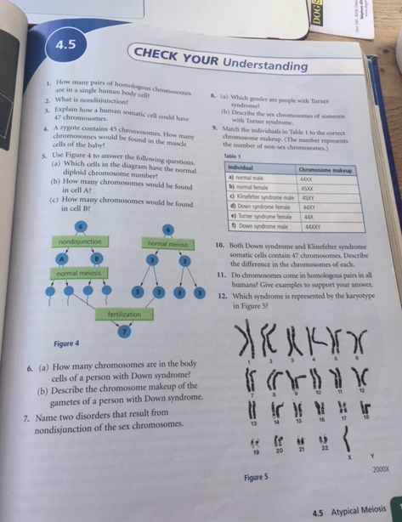
Page 129 Science Probe 9

- There are 22 pairs of homologous chromosomes in a single human body cell, and 2 sex chromosomes (which make another pair…but it is not homologous)
- Nondisjunction occurs when there are errors during meiosis, and when homologous chromosmes do not separate during meiosis. This results in gametes with the wrong number of chromosomes.
- In the case of Down Syndrome, a somatic cell could have 47 chromosomes by having 3 pairs of chromosome 21 (instead of 2). If a gamete with 24 chromosomes fertilizes with a gamete with 23 chromosomes, the resulting somatic cell could have 47 chromosomes.
- 45. Just like the zygote.
- A) the first line only ? B) 4 C)2
- A) 47 B) The zygote of a person with Down syndrome has 47 chromosomes. Thus, one gamete has 23 and the other 24 chromosomes.
- Turner Syndrome and Klinefelter syndrome
- A)Turner syndrome only exists in females and occurs when a female is born with one X chromosome. B) One of the gametes is missing from the sex chromosome, and as a result, the female reproductive organs do not develop at puberty and they do not menstruate and cannot reproduce.
- A) normal male: 44XY
B) normal female 44XX
c) Klinefelter syndrome male 44XXY
d) Down syndrome female 45XX
e) turner syndrome female 44X
f) down syndrome male 45XY
10) Down syndrome: the extra chromosome is a result of chromosome 21 which is not a sex chromosome. Klinefelter Syndrome: the extra chromosome is a result of the sex chromosome (two Xs rather than 1 X from the egg)
11) Generally, but there are exceptions….as in all generalisations. Consider someone with Down Syndrome. Chromosome 21 is not a homologous pair, but rather, there are three chromosomes.
12) Klinefelter syndrome

