Answers 4.6
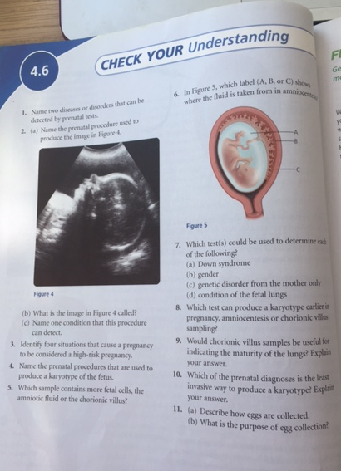
Page 132 Unit A: Reproduction, Science Probe 9

- Huntington’s Disease and Down Syndrome can be detected prior to birth.
- A) ultrasound B) sonogram (because it is made by sound waves) C) an ultrasound could be used to detect any physical absnormalities
- 1) if the woman is older than 35, 2) there are genetic conditions in the family, 3) the mother has already had a child with Down Syndrome, 4) the mother has had previous miscarriages
- Amniocentesis, Chorionic villus sampling,
- Chorionic villus
- A
- A) amniocentisis, chorionic villus sampling, and egg collection
B) ultrasound
C) egg collection
D) amniocentesis
- Chorionic villus sampling
- Not really. This is because the sample is taken so early in the pregnancy and cannot provide information regarding the fetus development.
- Eeeps….i don’t know
- A) An optical device called a laparoscope is inserted into the abdominal cavity to view the ovary. A suction device is then used to collect some eggs which are then tested in the laboratory. B) this is done to see if the egg’s are healthy, and to get more genetic information (i.e. nondisjunction indications, and genetic information passed on from the mother)

