Making Words with Chemical Symbols
Name: ____________________
Block: ________
We are going to take some time to get more familiar with the Periodic Table. To do this, we are going to make some words using Chemical Symbols.
Here are some silly examples:
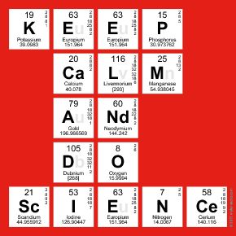
- Your job, is to make your own words or phrases using Chemical Symbols

Note that if a Chemical Symbol has one letter (for example, the Chemical Symbol for Oxygen is “O”) then the letter is capitalised!!
If the Chemical Symbol has two letters, then the first letter is capitalised and the second is lower case (for example, the Chemical Symbol for Calcium is Ca)
- Once you are done making your word, write out the names of the elements.
For example:

Write your word/phrase:

Part 2:
Now, that we are familiar with some Elements, let’s do a review. Play with the blocks that Ms. A is going to give you and draw a molecular diagram of an element, a compound, and a mixture
Make sure you use colour.
For fun…Try to name what elements/compounds could they be…any guesses.
Element | Compound | Mixture

